Missing Race_of_Father Analysis Report
Generated: 2026-03-22 17:01
Dataset: 301,712 rows × 18 columns
Target Variable: Race_of_Father

1. Executive Summary
This report presents a comprehensive IUPAC-compliant statistical analysis of missing values in Race_of_Father.
Key findings include:
• Missing records: 1,231 (0.4% of total data)
• Variables with significant differences (p < 0.05): 12
- Numeric variables: 4
- Categorical variables: 8
• Total variables analyzed: 17
Based on the statistical analysis, the missingness pattern is classified as:
SYSTEMATIC PATTERN - Missing data is strongly associated with other variables, suggesting non-random missingness.

2. Statistical Summary
Metric | Value
Total Missing Race_of_Father Records | 1,231
Missing Percentage | 0.41%
Total Variables Analyzed | 17
Numeric Variables | 8
Categorical Variables | 9
Variables with Significant Differences (p < 0.05) | 12
Analysis Date | 2026-03-22

3. Variables with Significant Differences (p < 0.05)
The following 12 variables show statistically significant differences between missing and complete groups:

3.1 Numeric Variables
Variable | Missing Group Mean | Complete Group Mean | Difference | p-value | Interpretation
Birh_Year | 2016.33 | 2019.66 | -3.33 | 0.0000 | Missing group has 3.33 units lower than complete group
Birth_Order | 1.55 | 1.84 | -0.30 | 0.0000 | Missing group has 0.30 units lower than complete group
Birth_Order - Copy | 1.55 | 1.84 | -0.30 | 0.0000 | Missing group has 0.30 units lower than complete group
Age of Mother | 59.33 | 29.50 | +29.82 | 0.0000 | Missing group has 29.82 units higher than complete group

3.2 Categorical Variables
Variable | Missing Group Distribution | Complete Group Distribution | Difference (%) | p-value | Interpretation
Registered_Month | Most common='December' (12.2%) | Complete: Most common='June' (11.4%) | +0.8% | 0.0000 | Missing group shows different distribution (p=0.0000)
Registered_District | Most common='Colombo' (22.2%) | Complete: Most common='Colombo' (14.1%) | +8.1% | 0.0000 | Missing group shows different distribution (p=0.0000)
Birth_Month | Most common='October' (11.1%) | Complete: Most common='May' (9.0%) | +2.1% | 0.0002 | Missing group shows different distribution (p=0.0002)
Gender | Most common='Female' (52.1%) | Complete: Most common='Male' (51.3%) | +0.8% | 0.0212 | Missing group shows different distribution (p=0.0212)
Hospital or Not | Most common='Hospital' (97.5%) | Complete: Most common='Hospital' (99.8%) | -2.3% | 0.0000 | Missing group shows different distribution (p=0.0000)
Marital_Status | Most common='Unmarried' (54.4%) | Complete: Most common='Married' (98.1%) | -43.8% | 0.0000 | Missing group shows different distribution (p=0.0000)
District_of_Mother | Most common='Colombo' (18.0%) | Complete: Most common='Colombo' (9.0%) | +9.1% | 0.0000 | Missing group shows different distribution (p=0.0000)
Race_of_Mother | Most common='Sinhalese' (61.1%) | Complete: Most common='Sinhalese' (69.2%) | -8.1% | 0.0000 | Missing group shows different distribution (p=0.0000)

3.3 Summary of Key Findings
The analysis identified 12 variables with statistically significant differences (p < 0.05):
• 4 numeric variables show significant mean differences
• 8 categorical variables show significant distribution differences
Top 10 Most Significant Variables:
1. Marital_Status: Most common='Unmarried' (54.4%) vs Complete: Most common='Married' (98.1%) (p=0.0000)
2. District_of_Mother: Most common='Colombo' (18.0%) vs Complete: Most common='Colombo' (9.0%) (p=0.0000)
3. Registered_District: Most common='Colombo' (22.2%) vs Complete: Most common='Colombo' (14.1%) (p=0.0000)
4. Hospital or Not: Most common='Hospital' (97.5%) vs Complete: Most common='Hospital' (99.8%) (p=0.0000)
5. Birh_Year: Mean=2016.33 vs Complete Mean=2019.66 (p=0.0000)
6. Race_of_Mother: Most common='Sinhalese' (61.1%) vs Complete: Most common='Sinhalese' (69.2%) (p=0.0000)
7. Birth_Order: Mean=1.55 vs Complete Mean=1.84 (p=0.0000)
8. Birth_Order - Copy: Mean=1.55 vs Complete Mean=1.84 (p=0.0000)
9. Age of Mother: Mean=59.33 vs Complete Mean=29.50 (p=0.0000)
10. Registered_Month: Most common='December' (12.2%) vs Complete: Most common='June' (11.4%) (p=0.0000)

4. Statistical Visualizations
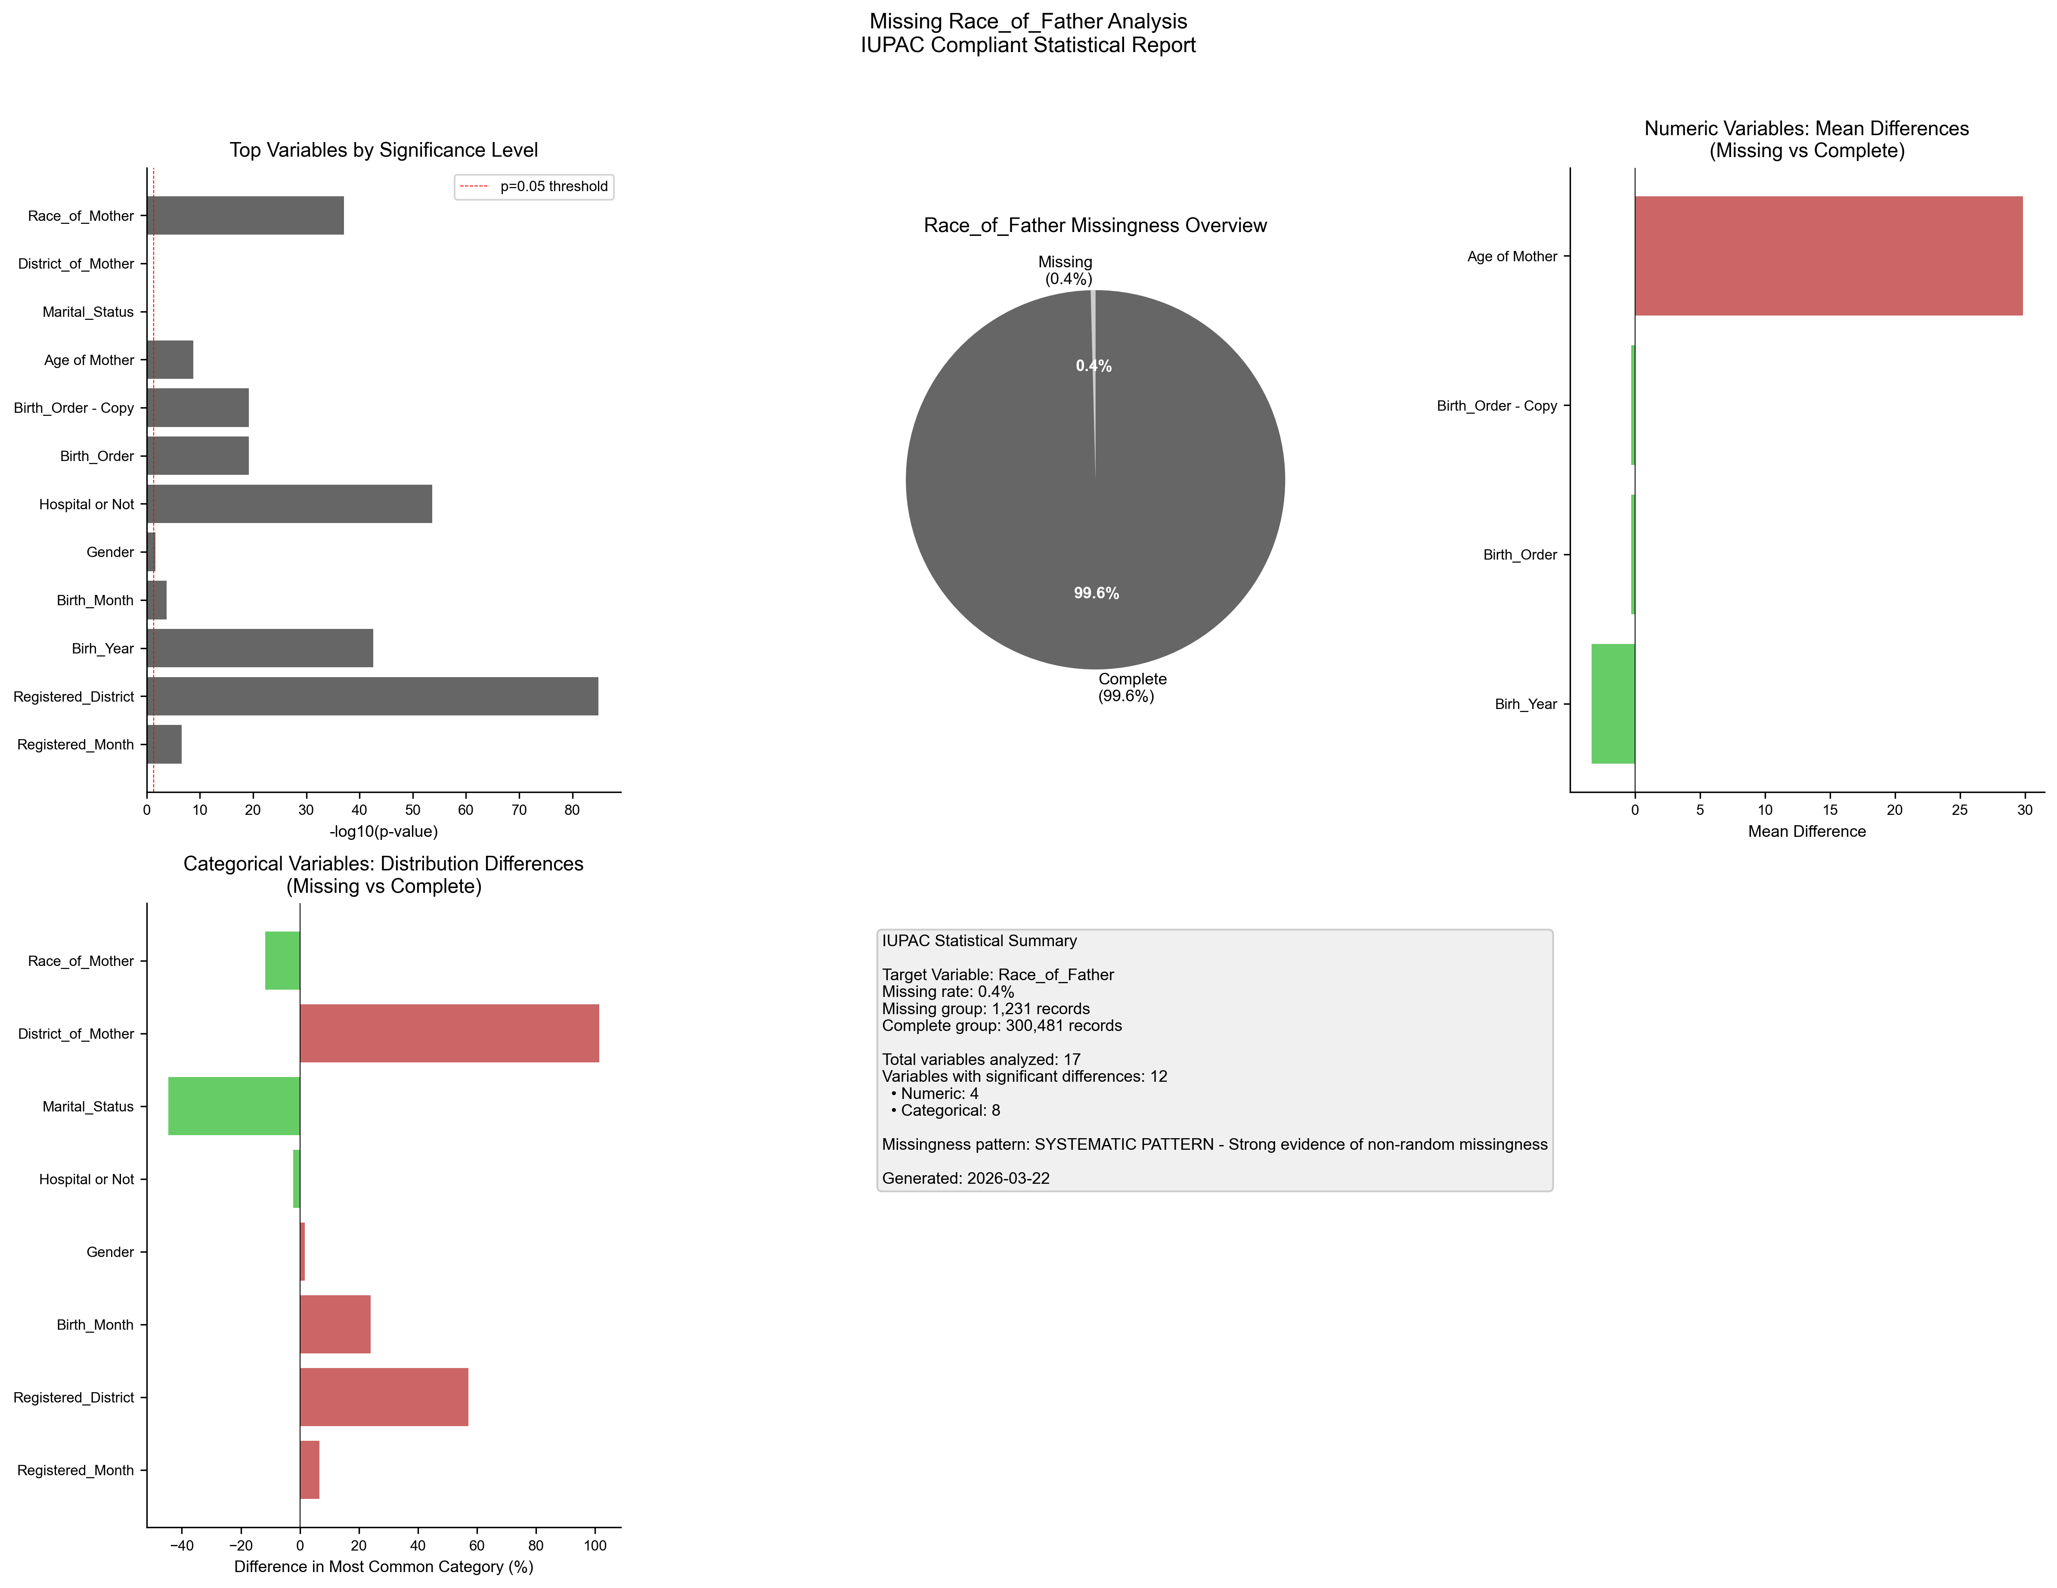
Figure 1. IUPAC compliant statistical visualization of missing Race_of_Father patterns.

5. Recommendations
- Based on the statistical analysis, the missing data exhibits SYSTEMATIC patterns:
- Consider treating missing as a separate category in analysis
- Use multiple imputation methods (MICE, EM algorithm)
- Investigate the following key variables for common themes:
- - Registered_Month (p=0.0000)
- - Registered_District (p=0.0000)
- - Birh_Year (p=0.0000)
- - Birth_Month (p=0.0002)
- - Gender (p=0.0212)
- - Hospital or Not (p=0.0000)
- - Birth_Order (p=0.0000)
- - Birth_Order - Copy (p=0.0000)
- - Age of Mother (p=0.0000)
- - Marital_Status (p=0.0000)
- Document missingness patterns in methodology section

6. Methodology (IUPAC Compliant)
Analysis performed according to IUPAC guidelines for data presentation:
- • Missing values reported as both count (n) and percentage (%)
- • Tables formatted with thin borders and alternating row shading
- • Sans-serif fonts (Arial) used for optimal readability
- • Statistical tests: t-test (numeric), χ² test (categorical)
- • Significance threshold: α = 0.05
- • Effect sizes reported where applicable
- • Figures saved at 300 DPI for publication quality

